**ASSIGNMENT 2 FRONT SHEET**

|  |  |  |  |
| --- | --- | --- | --- |
| **Qualification** | **BTEC Level 5 HND Diploma in Computing** | | |
| **Unit number and title** | Unit 2: Networking Infrastructure | | |
| **Submission date** | 3/1/2022 | **Date Received 1st submission** |  |
| **Re-submission Date** |  | **Date Received 2nd submission** |  |
| **Student Name** | Truong Van Tuan Kiet | **Student ID** | GCC200203 |
| **Class** | GCC0903 | **Assessor name** | Le Huynh Quoc Bao |
| **Student declaration**  I certify that the assignment submission is entirely my own work and I fully understand the consequences of plagiarism. I understand that making a false declaration is a form of malpractice. | | | |
|  |  | **Student’s signature** |  |

**Grading grid**

|  |  |  |  |  |  |  |  |
| --- | --- | --- | --- | --- | --- | --- | --- |
| P5 | P6 | P7 | P8 | M3 | M4 | D2 | D3 |
|  |  |  |  |  |  |  |  |

|  |  |  |
| --- | --- | --- |
| **❒ Summative Feedback: ❒ Resubmission Feedback:** | | |
| **Grade:** | **Assessor Signature:** | **Date:** |
| **Lecturer Signature:** | | |

# Assignment Brief 2 (RQF)

## Higher National Certificate/Diploma in Computing

|  |  |
| --- | --- |
| **Student Name/ID Number:** |  |
| **Unit Number and Title:** | **Unit 2: Networking** |
| **Academic Year:** | **2021 – 2022** |
| **Unit Assessor:** | **Van Ho** |
| **Assignment Title:** | **Networking Infrastructure** |
| **Issue Date:** | **April 1st, 2021** |
| **Submission Date:** |  |
| **Internal Verifier Name:** |  |
| **Date:** |  |

|  |
| --- |
| **Submission Format:** |
| *Format:*   * The submission is in the form of an individual written report. This should be written in a concise, formal business style using single spacing and font size 12. You are required to make use of headings, paragraphs and subsections as appropriate, and all work must be supported with research and referenced using the Harvard referencing system. Please also provide a bibliography using the Harvard referencing system.   *Submission*   * Students are compulsory to submit the assignment in due date and in a way requested by the Tutor. * The form of submission will be a soft copy posted on <http://cms.greenwich.edu.vn/>. * Remember to convert the word file into PDF file before the submission on CMS.   *Note:*   * The individual Assignment *must* be your own work, and not copied by or from another student. * If you use ideas, quotes or data (such as diagrams) from books, journals or other sources, you must reference your sources, using the Harvard style. * Make sure that you understand and follow the guidelines to avoid plagiarism. Failure to comply this requirement will result in a failed assignment. |
| **Unit Learning Outcomes:** |
| **LO3** Design efficient networked systems.  **LO4** Implement and diagnose networked systems. |
| **Assignment Brief and Guidance:** |
| **Assignment scenario** (cont.)  The CEO Mr. Nguyen is happy with your first report and now he has asked you to analyse the specification from the institution, as given earlier.  You need to design and implement the networking project within a given timeframe:  **Task 2**  Design efficient networked systems:   * Prepare a written step-by-step plan of how you are going to design a Local Area Network including a blueprint of your LAN. * Justify your choice of devices for your network design. * Produce a test plan to evaluate this design for the requirements of bandwidth and cost constraints as per user specifications. * Justify the security requirements and quality of services needed for selection of accessories. * Suggest a maintenance schedule to support the networked system.   **Task 3**  Implement test and diagnose networked systems:   * Implement a networked system based on your prepared design. * Conduct verification with, e.g., Ping, extended ping, trace route, telnet, SSH, etc. * Record the test results and analyse these against expected results. * Investigate what functionalities would allow the system to support device growth and the addition of communication devices. * Discuss the significance of upgrades and security requirements in your recommendations. |

|  |  |  |  |
| --- | --- | --- | --- |
| **Learning Outcomes and Assessment Criteria (Assignment 1):** | | | |
| Learning Outcome | Pass | Merit | Distinction |
| **LO3** | **P5** Provide a logical/physical design of the networked system with clear explanation and addressing table.  **P6** Evaluate the design to meet the requirements. | **M3** Install and configure network services and applications on your choice. | **D2** Design a maintenance schedule to support the networked system. |
| **LO4** | **P7** Implement a networked system based on a prepared design.  **P8** Document and analyse test results against expected results. | **M4** Recommend potential enhancements for the networked systems. | **D3** Use critical reflection to evaluate own work and justify valid conclusions. |

**Table Of Content**

**Assignment Brief 2 (RQF) 2**

Higher National Certificate/Diploma in Computing 2

**I. Provide a logical/physical design of the networked system with clear explanation and addressing table. 6**

1. Difference between logical and physical design. 6

2. Requirements and solutions. 8

3. Logical design of the network base on user requirements. 9

4. Physical design of the network based on user requirements. 13

5. Addressing table for the network. 17

**II. Evaluate the design to meet the requirements. 20**

1. Test plan. 20

2. Advantages and disadvantages of the network. 21

3. Advice to the network work better. 21

**III. Implement a networked system based on a prepared design. 21**

1. Create VLANs. 21

2. Set switch port for VLANs. 22

3. Set IP address to VLANs. 23

4. Set DHCP services. 24

**IV. Document and analyse test results against expected results. 26**

1. Set IP address to device. 26

2. Test the connection. 39

**References 44**

**Assignment 2**

1. **Provide a logical/physical design of the networked system with clear explanation and addressing table.**
2. **Difference between logical and physical design.**

When we look at the differences between logical design and physical design of a network it is easy to think of it as the logical as the functional part and physical as the seeing it part.

With that stated there is more to this than just the functional and seeing parts. In order to understand the differences from one to the other, we need more information. In the following paragraphs I will try to outline what makes up the differences between logical and physical design of a network. So let's first look at what constitutes a logical design of a network.

The first thing we know is that the logical design is, "The part of the design phase of the SDLC in which all functional features of the network chose for development are described independently of any computer platform." There are other ways to describe a logical network, but the one that comes to mind is how the network will be structured. Basically we are talking about all of the logical aspects of the network. According to Webopedia, "the logical topology is the way the data passes through the network from one device to the next without regard to physical interconnection of the devices.

"Also the logical design lacks specific details such as technologies and standards and focuses on the general needs of the network. A logical design can be a view of any part of the network, whether it be the whole or just a part of it. Another element of the logical design is the IP addresses and their association with the different parts of the network. The IP addresses are assign to devices such as routers, switches, servers, workstations, and other devices that utilize the network.

In the logical design we usually do not show the actual interfaces and physical cables in the diagrams; thus giving us the true meaning of the term "logical." IP structure is a big part of the logical design of a network as well as security planning. A good logical design will have the foundation for security which provides the framework stages needed for security. Each layer should have scalable security services that involve the routers, switches, servers, workstations and other devices that are utilizing the network.

In some cases the logical design is described using the terms of the customer's business. Processes, roles, and even locations can show up in the logical design; however, the important aspect of the logical design is that it is part of the requirement set for a solution to a customer's problem (Jim's Weblog, 2005). Below is an illustrated example of a logical design of a network: Now that we have looked at the logical design, let's take a look at the physical design of a network. The basic idea behind the physical design is to communicate what hardware should be used in the network.

The physical design of the network is derived from the logical design and the physical design will often expand on the elements found in the logical design. For example, let's say that the logical design shows a WAN connection as line between to buildings. When this is transformed into a physical design, that single line could expand into the connection, routers and other equipment at each end of the connection (Jim's Weblog, 2005). The physical design also involves the specific technologies and products that are realized from the logical design.

This involves the actual devices that will be used to get the logical design to work. The physical design also will involve the topology that will be used in the network. The physical topologies vary and there are many to choose from such as the Ring topology, the Bus topology, the Star topology, the Mesh and many others depending on the needs of the customer. A Ring topology would be: All devices are connected to one another in the shape of a closed loop, so that each device is connected directly to two other devices, one on either side of it (Webopedia, 2006).

A Bus topology would be: All devices are connected to a central cable, called the bus or backbone. Bus networks are relatively inexpensive and easy to install for small networks. Ethernet systems use a bus topology. A Star topology would be: All devices are connected to a central hub.

Star networks are relatively easy to install and manage, but bottlenecks can occur because all data must pass through the hub (Webopedia, 2006). So when we refer to the physical design we are talking about the actual physical layout of the network. This includes the cables, switches, workstations, routers, and servers. The physical design involves a diagram of the actual way the network will be seen.

Below is an illustrated example of the physical design of a network: In conclusion, the difference between logical design and physical design of a network is in the way they are presented. The logical being the one that shows how the data flows and the physical showing the devices and connections of the network. You can think of logical and physical as like cars and roads. The roads represent the physical network where each road is interconnected and the cars represent the logical where when they move towards a certain destination within the network.

Although logical and physical networks vary, they still work together to better define the same network.

(GraduateWAY, 2021)

1. **Requirements and solutions.**

**Requirements:**

- The network transfer rate to meet user needs. The network can accommodate more than 200 users during - peak hours with high-speed access and stability.

- The devices in the network can connect together with a good connection.

- The network can develop in the future.

- The network can develop in the future.

**The specification of the project is given below:**

- People: 200 students, 15 teachers, 12 marketing and administration staff, 5 higher managers including the academic heads and the program managers, and 3 computer network administrators.

- Resources: 50 student lab computers, 35 staff computers, and 3 printers.

- Building: 3 floors, all computers and printers are on the ground floor apart from the IT labs – one lab located on the first floor and another located on the second floor.

**Solutions:**

Thus my design will include 6 rooms including: 1 room for staff IT and severs, 1 room for the manager, 1 room for staff, on the first floor 1 room for IT lab, and on the second-floor 1room for the IT lab.

**Network devices and terminals chose:**

- Switch: connects PC and PC, PC and printer, PC and server

- Router: transmits data through layers, from switches.

- PC: Is the network / client connection

- Server: shares data and resources; divides task to staffs, admins, teachers, managers.

- Printer: Receive and provide text documents for teachers, administrators, staff, and manager.

1. **Logical design of the network base on user requirements.**

**Overall logical design**

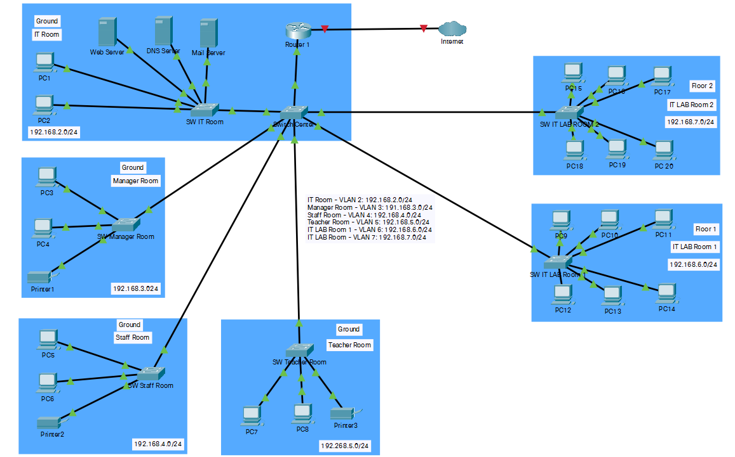

**IT Room logical design**

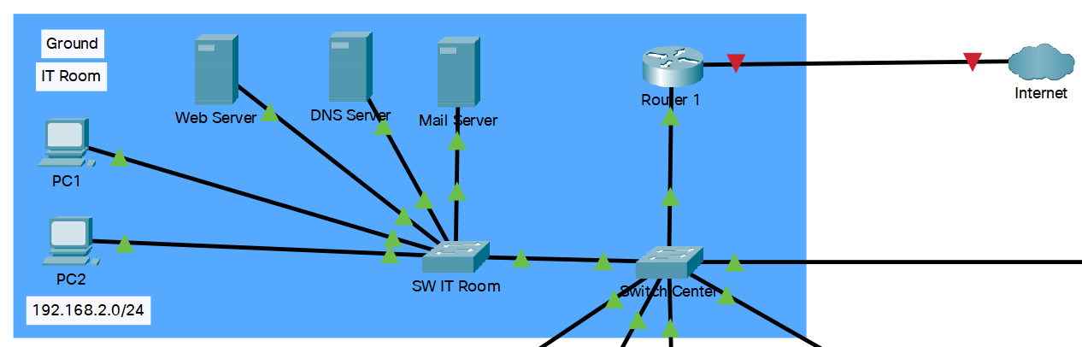

**Manager Room logical design**

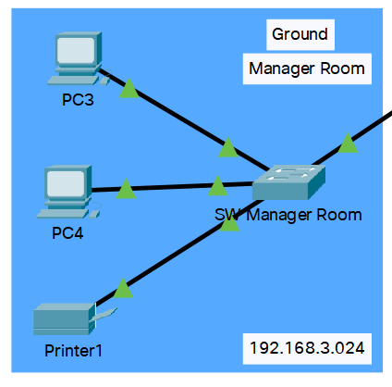

**Staff Room logical design**

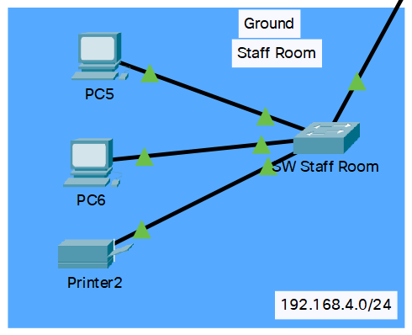

**Teacher Room logical design**

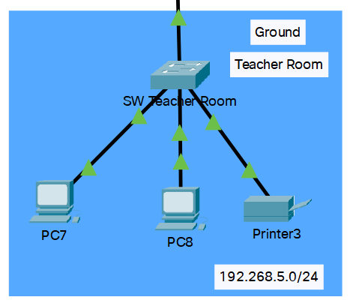

**IT LAB Room logical design**

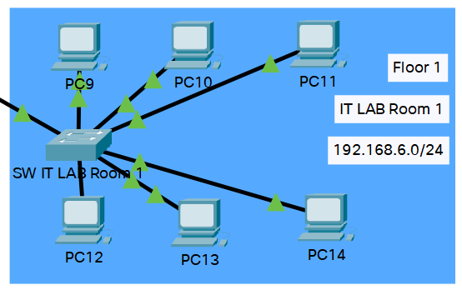

**IT LAB Room 2 logical design**

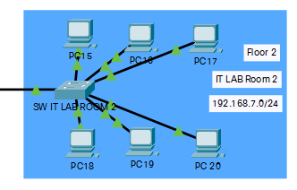

1. **Physical design of the network based on user requirements.**

**Overall physical design**

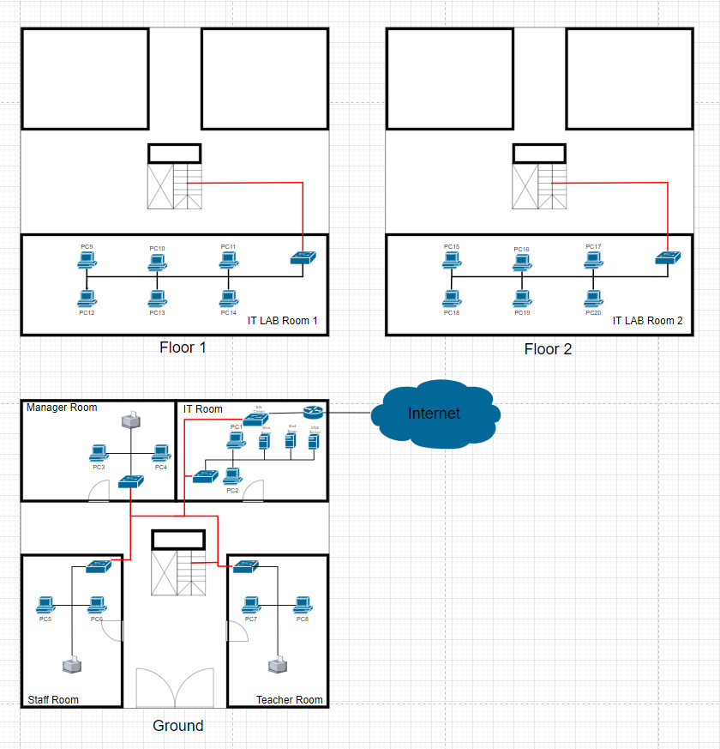

**Ground physical design**

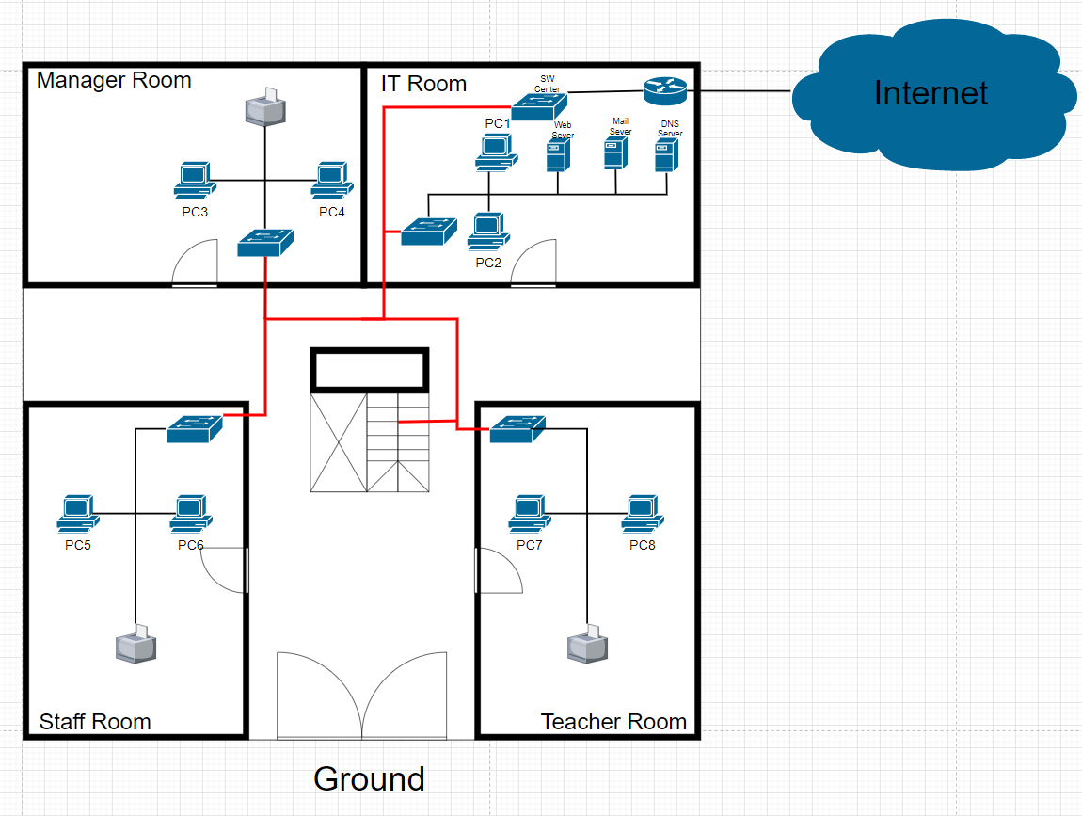

**Floor 1 physical design**

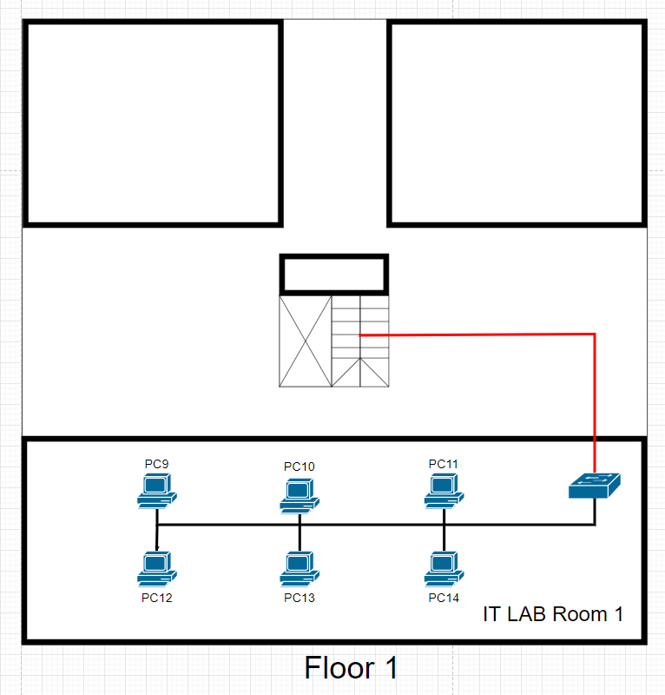

**Floor 2 physical design:**

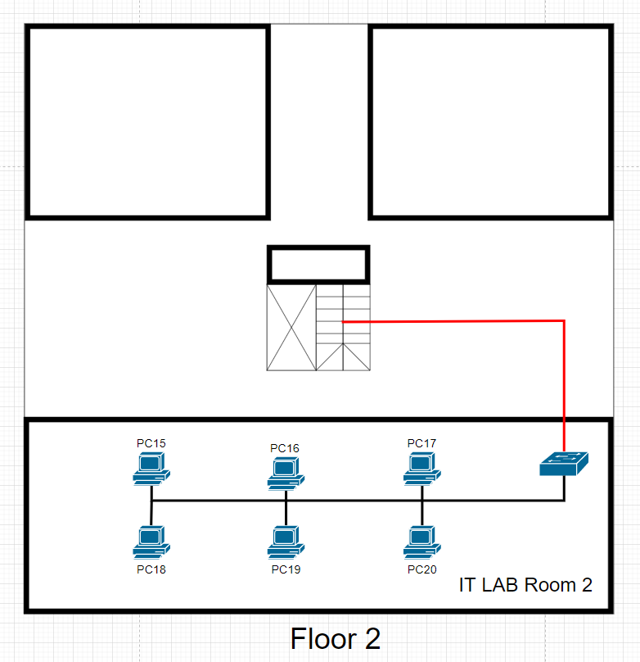

1. **Addressing table for the network.**

**IP address table:**

|  |  |  |  |  |
| --- | --- | --- | --- | --- |
| **Device** | **Interface** | **IP address** | **Subnet mask** | **Default gateway** |
| R1 | GigabitEthernet0/0 | 192.168.1.1 | 255.255.255.0 | N/A |
| R1 | GigabitEthernet0/0.2 | 192.168.2.1 | 255.255.255.0 | N/A |
| R1 | GigabitEthernet0/0.3 | 192.168.3.1 | 255.255.255.0 | N/A |
| R1 | GigabitEthernet0/0.4 | 192.168.4.1 | 255.255.255.0 | N/A |
| R1 | GigabitEthernet0/0.5 | 192.168.5.1 | 255.255.255.0 | N/A |
| R1 | GigabitEthernet0/0.6 | 192.168.6.1 | 255.255.255.0 | N/A |
| R1 | GigabitEthernet0/0.7 | 192.168.7.1 | 255.255.255.0 | N/A |
| Switch Center | Vlan 2 | 192.168.2.5 | 255.255.255.0 | N/A |
| Switch Center | Vlan 3 | 192.168.3.5 | 255.255.255.0 | N/A |
| Switch Center | Vlan 4 | 192.168.4.5 | 255.255.255.0 | N/A |
| Switch Center | Vlan 5 | 192.168.5.5 | 255.255.255.0 | N/A |
| Switch Center | Vlan 6 | 192.168.6.5 | 255.255.255.0 | N/A |
| Switch Center | Vlan 7 | 192.168.7.5 | 255.255.255.0 | N/A |
| Switch SW IT Room | DHCP pool dhcp1 | 192.168.2.0 | 255.255.255.0 | 192.168.2.1 |
| Switch SW IT Room | Vlan 1 | 192.168.2.6 | 255.255.255.0 | N/A |
| PC1 | FastEthernet0 | Service DHCP by SW IT Room | Service DHCP by SW IT Room | Service DHCP by SW IT Room |
| PC2 | FastEthernet0 | Service DHCP by SW IT Room | Service DHCP by switch SW IT Room | Service DHCP by switch SW IT Room |
| Web Server | FastEthernet0 | 192.168.2.10 | 255.255.255.0 | 192.168.2.1 |
| DNS Server | FastEthernet0 | 192.168.2.11 | 255.255.255.0 | 192.168.2.1 |
| Mail Server | FastEthernet0 | 192.168.2.12 | 255.255.255.0 | 192.168.2.1 |
| Switch SW Manager Room | DHCP pool dhcp1 | 192.168.3.0 | 255.255.255.0 | 192.168.3.1 |
| Switch SW Manager Room | Vlan 1 | 192.168.3.6 | 255.255.255.0 | N/A |
| PC3 | FastEthernet0 | Service DHCP by SW Manger Room | Service DHCP by SW Manger Room | Service DHCP by SW Manger Room |
| PC4 | FastEthernet0 | Service DHCP by SW Manger Room | Service DHCP by SW Manger Room | Service DHCP by SW Manger Room |
| Printer 1 | FastEthernet0 | Service DHCP by SW Manger Room | Service DHCP by SW Manger Room | Service DHCP by SW Manger Room |
| Switch SW Staff Room | DHCP pool dhcp1 | 192.168.4.0 | 255.255.255.0 | 192.168.4.1 |
| Switch SW Staff Room | Vlan 1 | 192.168.4.6 | 255.255.255.0 | N/A |
| PC5 | FastEthernet0 | Service DHCP by SW Staff Room | Service DHCP by SW Staff Room | Service DHCP by SW Staff Room |
| PC6 | FastEthernet0 | Service DHCP by SW Staff Room | Service DHCP by SW Staff Room | Service DHCP by SW Staff Room |
| Printer 2 | FastEthernet0 | Service DHCP by SW Staff Room | Service DHCP by SW Staff Room | Service DHCP by SW Staff Room |
| Switch SW Teacher Room | DHCP pool dhcp1 | 192.168.5.0 | 255.255.255.0 | 192.168.5.1 |
| Switch SW Teacher Room | Vlan 1 | 192.168.5.6 | 255.255.255.0 | N/A |
| PC7 | FastEthernet0 | Service DHCP by SW Teacher Room | Service DHCP by SW Teacher Room | Service DHCP by SW Teacher Room |
| PC8 | FastEthernet0 | Service DHCP by SW Teacher Room | Service DHCP by SW Teacher Room | Service DHCP by SW Teacher Room |
| Printer 3 | FastEthernet0 | Service DHCP by SW Teacher Room | Service DHCP by SW Teacher Room | Service DHCP by SW Teacher Room |
| Switch SW LAB Room 1 | DHCP pool dhcp1 | 192.168.6.0 | 255.255.255.0 | 192.168.6.1 |
| Switch SW LAB Room 1 | Vlan 1 | 192.168.6.6 | 255.255.255.0 | N/A |
| PC9 | FastEthernet0 | Service DHCP by SW LAB Room 1 | Service DHCP by SW LAB Room 1 | Service DHCP by SW LAB Room 1 |
| PC10 | FastEthernet0 | Service DHCP by SW LAB Room 1 | Service DHCP by SW LAB Room 1 | Service DHCP by SW LAB Room 1 |
| PC11 | FastEthernet0 | Service DHCP by SW LAB Room 1 | Service DHCP by SW LAB Room 1 | Service DHCP by SW LAB Room 1 |
| PC12 | FastEthernet0 | Service DHCP by SW LAB Room 1 | Service DHCP by SW LAB Room 1 | Service DHCP by SW LAB Room 1 |
| PC13 | FastEthernet0 | Service DHCP by SW LAB Room 1 | Service DHCP by SW LAB Room 1 | Service DHCP by SW LAB Room 1 |
| PC14 | FastEthernet0 | Service DHCP by SW LAB Room 1 | Service DHCP by SW LAB Room 1 | Service DHCP by SW LAB Room 1 |
| Switch SW LAB Room 2 | DHCP pool dhcp1 | 192.168.7.0 | 255.255.255.0 | 192.168.7.1 |
| Switch SW LAB Room 2 | Vlan 1 | 192.168.7.6 | 255.255.255.0 | N/A |
| PC15 | FastEthernet0 | Service DHCP by SW LAB Room 2 | Service DHCP by SW LAB Room 2 | Service DHCP by SW LAB Room 2 |
| PC16 | FastEthernet0 | Service DHCP by SW LAB Room 2 | Service DHCP by SW LAB Room 2 | Service DHCP by SW LAB Room 2 |
| PC17 | FastEthernet0 | Service DHCP by SW LAB Room 2 | Service DHCP by SW LAB Room 2 | Service DHCP by SW LAB Room 2 |
| PC18 | FastEthernet0 | Service DHCP by SW LAB Room 2 | Service DHCP by SW LAB Room 2 | Service DHCP by SW LAB Room 2 |
| PC19 | FastEthernet0 | Service DHCP by SW LAB Room 2 | Service DHCP by SW LAB Room 2 | Service DHCP by SW LAB Room 2 |
| PC20 | FastEthernet0 | Service DHCP by SW LAB Room 2 | Service DHCP by SW LAB Room 2 | Service DHCP by SW LAB Room 2 |

1. **Evaluate the design to meet the requirements.**
2. **Test plan.**

**Test plan table:**

|  |  |  |
| --- | --- | --- |
| **NO** | **Activity** | **Reason** |
| 1 | Ping from PC 4 to Web server | Test the ability to connect to the website of the network. |
| 2 | Ping from PC5 to Printer 2 | Test the ability to connect to the other devices of the network. |
| 3 | Ping from PC1 to PC20 | Test the ability to connect between two PCs of the network. |
| 4 | Ping from PC15 to DNS server | Test the ability to Domain name resolution of the network. |
| 5 | Ping from PC10 to Mail server | Test the ability to send and receive Emails of the network. |

1. **Advantages and disadvantages of the network.**

**Advantages:**

- This type of topology facilitates the connection of devices to one another

- Add or uninstall PCs without network messing up. Adding devices would not impact the entire network link, so it won't take long to reconfigure

- This topology makes the implementation of networks very easy.

- Unlimited number of devices added.

**Disadvantages:**

This network uses LAN network, so the disadvantages of LAN cannot be avoided, such as:

- The initial cost is quite high because purchasing hardware equipment such as routers, hubs, switches, and cables is required for the first-time setup.

- LAN often faces hardware problems and system failure.

- Area coverage is limited.

- Server crashes all the connected computers are affected too.

1. **Advice to the network work better.**

- Shouldn't access unreliable websites, they can steal information and crash the network.

- Usually, inspect and maintain the network. Early detection of damage reduces repair costs and time.

- Monitor the network. IT admins monitor the network to help detect unauthorized users to avoid being stolen information and crashing the network.

1. **Implement a networked system based on a prepared design.**
2. **Create VLANs.**

SwitchCenter>enable

SwitchCenter#configure terminal

SwitchCenter(config)#vlan 2

SwitchCenter(config-vlan)#exit

SwitchCenter(config)#vlan 3

SwitchCenter(config-vlan)#exit

SwitchCenter(config)#vlan 4

SwitchCenter(config-vlan)#exit

SwitchCenter(config)#vlan 5

SwitchCenter(config-vlan)#exit

SwitchCenter(config)#vlan 6

SwitchCenter(config-vlan)#exit

SwitchCenter(config)#vlan 7

SwitchCenter(config-vlan)#exit

1. **Set switch port for VLANs.**

**- Vlan 2:**

SwitchCenter(config)#interface range fastEthernet 0/1-4

SwitchCenter(config-if-range)#switchport access vlan 2

SwitchCenter(config-if-range)#exit

**- Vlan 3:**

SwitchCenter(config)#interface range fastEthernet 0/5-8

SwitchCenter(config-if-range)#switchport access vlan 3

SwitchCenter(config-if-range)#exit

**- Vlan 4:**

SwitchCenter(config)#interface range fastEthernet 0/9-12

SwitchCenter(config-if-range)#switchport access vlan 4

SwitchCenter(config-if-range)#exit

**- Vlan 5:**

SwitchCenter(config)#interface range fastEthernet 0/13-16

SwitchCenter(config-if-range)#switchport access vlan 5

SwitchCenter(config-if-range)#exit

**- Vlan 6:**

SwitchCenter(config)#interface range fastEthernet 0/17-20

SwitchCenter(config-if-range)#switchport access vlan 6

SwitchCenter(config-if-range)#exit

**- Vlan 7:**

SwitchCenter(config)#interface range fastEthernet 0/21-24

SwitchCenter(config-if-range)#switchport access vlan 2

SwitchCenter(config-if-range)#exit

1. **Set IP address to VLANs.**

**- Vlan 2:**

R1(config)#interface G0/0.2

R1(config-subif)#encapsulation dotIQ 2

R1(config-subif)#ip add 192.168.2.1 255.255.255.0

R1(config-subif)#no shutdown

R1(config-subif)#exit

**- Vlan 3:**

R1(config)#interface G0/0.3

R1(config-subif)#encapsulation dotIQ 3

R1(config-subif)#ip add 192.168.3.1 255.255.255.0

R1(config-subif)#no shutdown

R1(config-subif)#exit

**- Vlan 4:**

R1(config)#interface G0/0.4

R1(config-subif)#encapsulation dotIQ 4

R1(config-subif)#ip add 192.168.4.1 255.255.255.0

R1(config-subif)#no shutdown

R1(config-subif)#exit

**- Vlan 5:**

R1(config)#interface G0/0.5

R1(config-subif)#encapsulation dotIQ 5

R1(config-subif)#ip add 192.168.5.1 255.255.255.0

R1(config-subif)#no shutdown

R1(config-subif)#exit

**- Vlan 6:**

R1(config)#interface G0/0.5

R1(config-subif)#encapsulation dotIQ 6

R1(config-subif)#ip add 192.168.6.1 255.255.255.0

R1(config-subif)#no shutdown

R1(config-subif)#exit

**- Vlan 7:**

R1(config)#interface G0/0.7

R1(config-subif)#encapsulation dotIQ 7

R1(config-subif)#ip add 192.168.7.1 255.255.255.0

R1(config-subif)#no shutdown

R1(config-subif)#exit

1. **Set DHCP services.**

**- IT Room:**

SWITRoom(config)#ip dhcp excluded-address 192.168.2.1 192.168.2.20

SWITRoom(config)#ip dhcp pool DHCP1

SWITRoom(dhcp-config)#network 192.168.2.0 255.255.255.0

SWITRoom(dhcp-config)#default-router 192.168.2.1

SWITRoom(dhcp-config)#dns-server 192.168.2.11

SWITRoom(dhcp-config)#exit

SWITRoom(config)#interface vlan 1

SWITRoom(config-if)#ip address 192.168.2.6 255.555.0

SSWITRoom(config-if)#no shutdown

SWITRoom(config-if)#exit

**- Manager Room:**

SWManagerRoom(config)#ip dhcp excluded-address 192.168.3.1 192.168.3.20

SWManagerRoom(config)#ip dhcp pool DHCP1

SWManagerRoom(dhcp-config)#network 192.168.3.0 255.255.255.0

SWManagerRoom(dhcp-config)#default-router 192.168.3.1

SWManagerRoom(dhcp-config)#dns-server 192.168.2.11

SWManagerRoom(dhcp-config)#exit

SWManagerRoom(config)#interface vlan 1

SWManagerRoom(config-if)#ip address 192.168.3.6 255.555.0

SWManagerRoom(config-if)#no shutdown

SWManagerRoom(config-if)#exit

**- Staff Room:**

SWStaffRoom(config)#ip dhcp excluded-address 192.168.4.1 192.168.4.20

SWStaffRoom(config)#ip dhcp pool DHCP1

SWStaffRoom(dhcp-config)#network 192.168.4.0 255.255.255.0

SWStaffRoom(dhcp-config)#default-router 192.168.4.1

SWStaffRoom(dhcp-config)#dns-server 192.168.2.11

SWStaffRoom(dhcp-config)#exit

SWStaffRoom(config)#interface vlan 1

SWStaffRoom(config-if)#ip address 192.168.4.6 255.555.0

SWStaffRoom(config-if)#no shutdown

SWStaffRoom(config-if)#exit

**- Teacher Room:**

SWTeacherRoom(config)#ip dhcp excluded-address 192.168.5.1 192.168.5.20

SWTeacherRoom(config)#ip dhcp pool DHCP1

(dhcp-config)#network 192.168.5.0 255.255.255.0

SWTeacherRoom(dhcp-config)#default-router 192.168.5.1

SWTeacherRoom(dhcp-config)#dns-server 192.168.2.11

SWTeacherRoom(dhcp-config)#exit

SWTeacherRoom(config)#interface vlan 1

SWTeacherRoom(config-if)#ip address 192.168.5.6 255.555.0

SWTeacherRoom(config-if)#no shutdown

SWTeacherRoom(config-if)#exit

**- IT LAB Room 1:**

SWITLabRoom1(config)#ip dhcp excluded-address 192.168.6.1 192.168.6.20

SWITLabRoom1(config)#ip dhcp pool DHCP1

SWITLabRoom1(dhcp-config)#network 192.168.6.0 255.255.255.0

SWITLabRoom1(dhcp-config)#default-router 192.168.6.1

SWITLabRoom1(dhcp-config)#dns-server 192.168.2.11

SWITLabRoom1(dhcp-config)#exit

SWITLabRoom1(config)#interface vlan 1

SWITLabRoom1(config-if)#ip address 192.168.6.6 255.555.0

SWITLabRoom1(config-if)#no shutdown

SWITLabRoom1(config-if)#exit

**- IT LAB Room 2:**

SWITLabRoom2(config)#ip dhcp excluded-address 192.168.7.1 192.168.7.20

SWITLabRoom2(config)#ip dhcp pool DHCP1

SWITLabRoom2(dhcp-config)#network 192.168.7.0 255.255.255.0

SWITLabRoom2(dhcp-config)#default-router 192.168.7.1

SWITLabRoom2(dhcp-config)#dns-server 192.168.2.11

SWITLabRoom2(dhcp-config)#exit

SWITLabRoom2(config)#interface vlan 1

SWITLabRoom2(config-if)#ip address 192.168.7.6 255.555.0

SWITLabRoom2(config-if)#no shutdown

SWITLabRoom2(config-if)#exit

1. **Document and analyse test results against expected results.**
2. **Set IP address to device.**

**Set IP address to Web Sever**

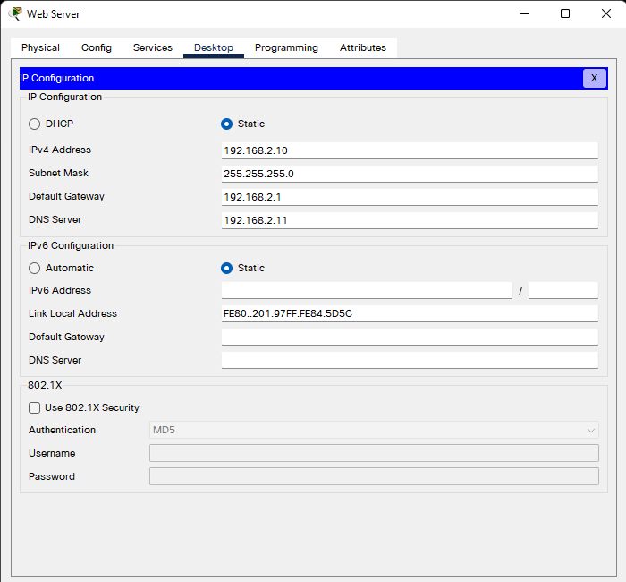

**Set IP address to DNS Server**

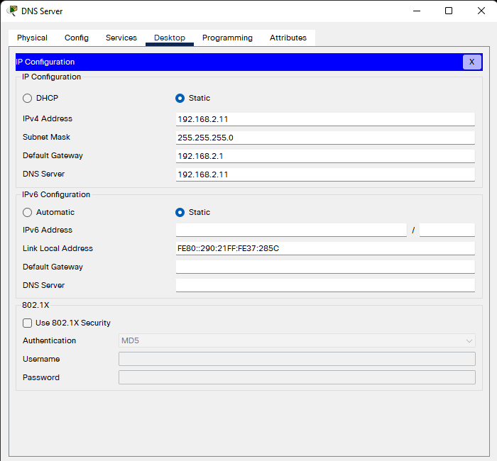

**Set IP address to Mail Sever**

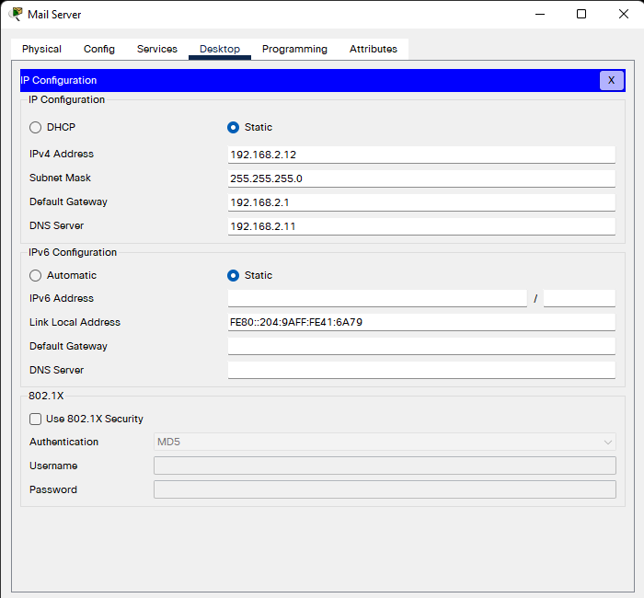

**Set IP address to devices in IT Room**

- Set IP address to PC1

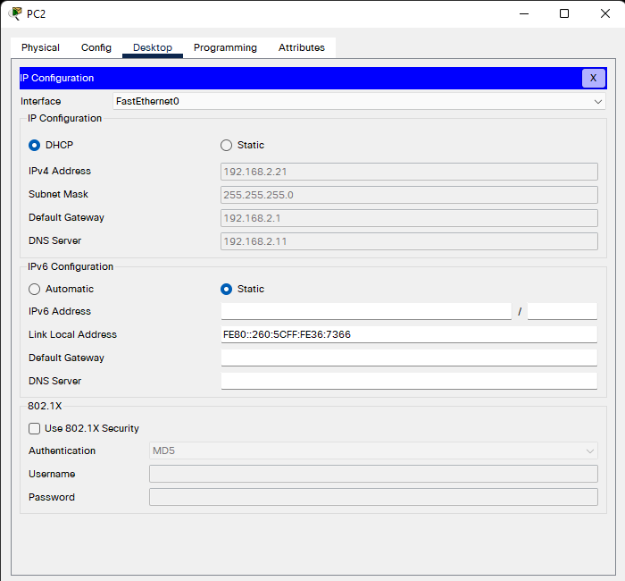

- Set IP address to PC 2

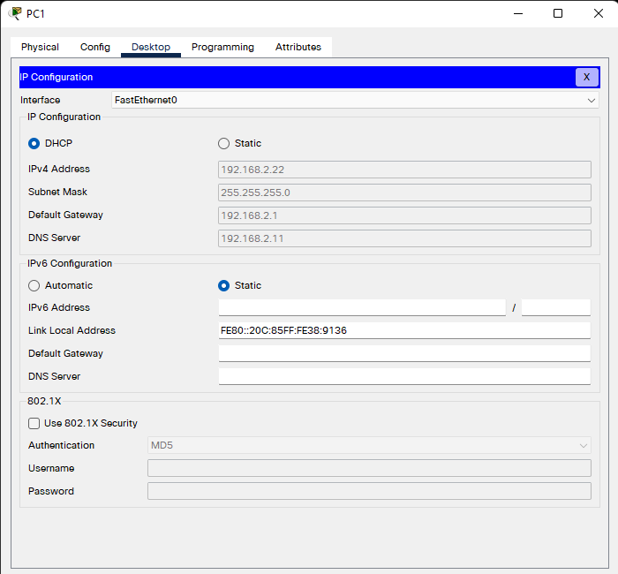

**Set IP address to devices in Manager Room**

- Set IP address to PC 3

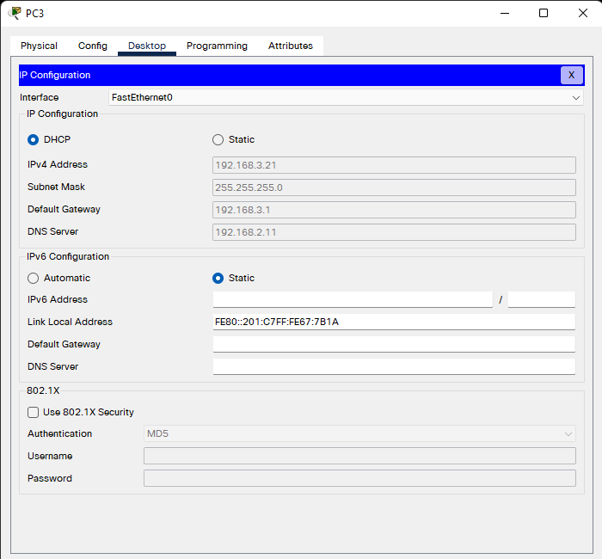

- Set IP address to PC 4

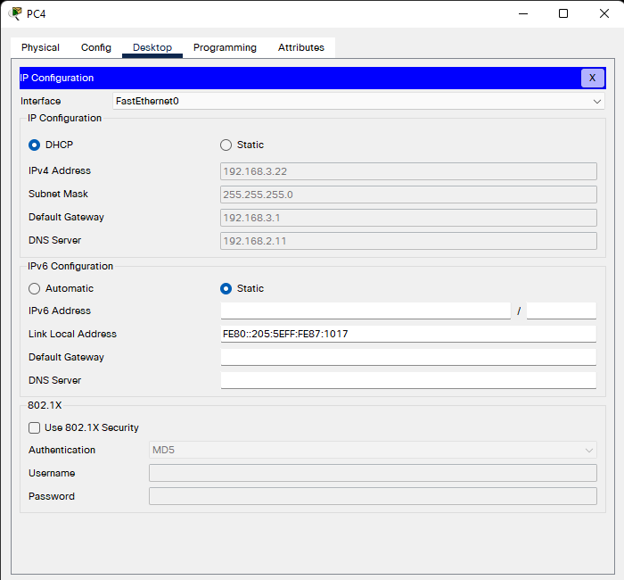

- Set IP address to Printer 1

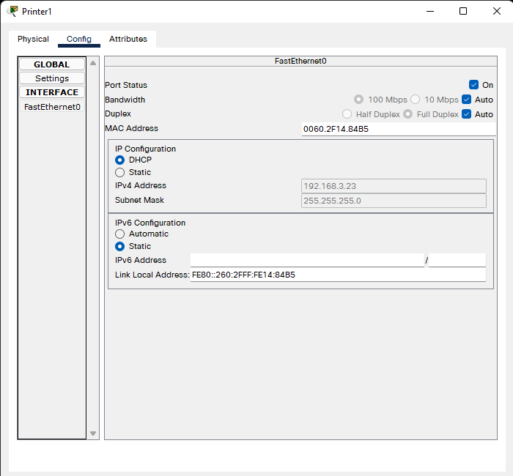

**Set IP address to devices in Staff Room**

- Set IP address to PC5

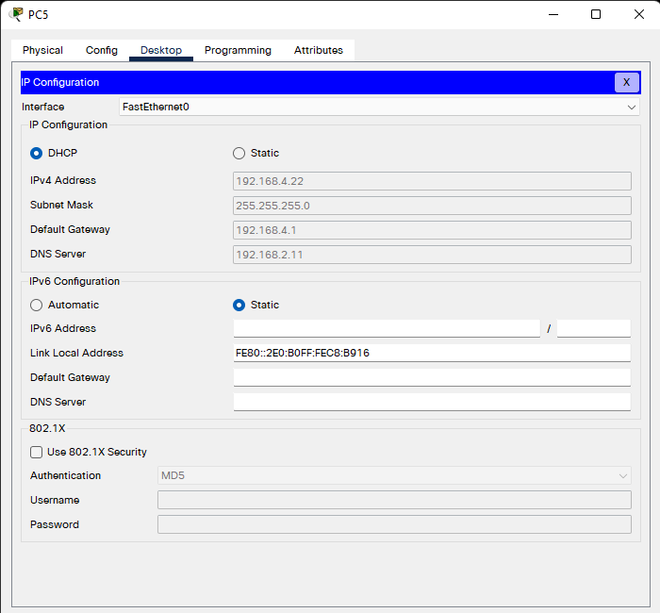

- Set IP address to PC6

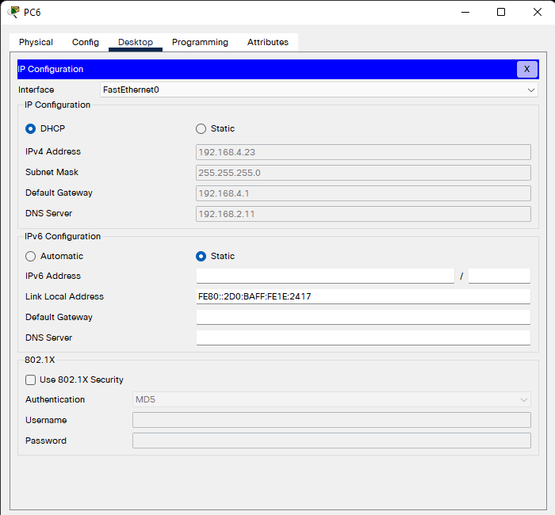

- Set IP address to Printer 2

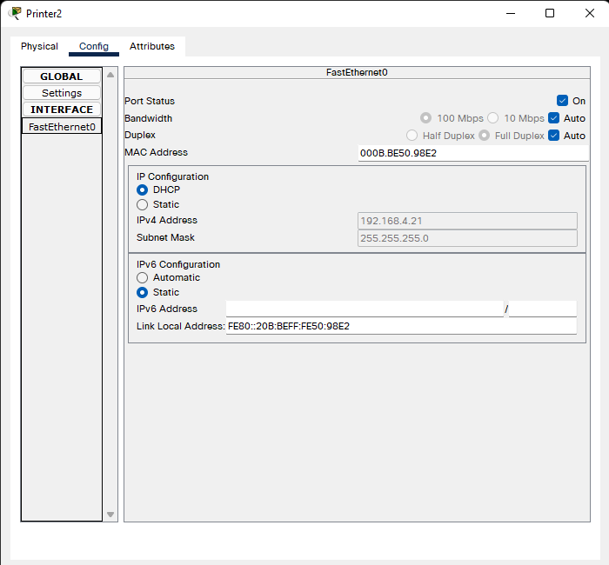

**Set IP address to devices in Teacher Room**

- Set IP address to PC 7

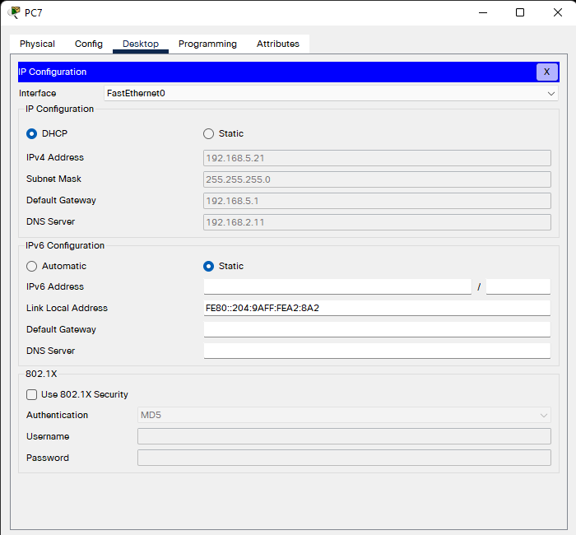

- Set IP address to PC8

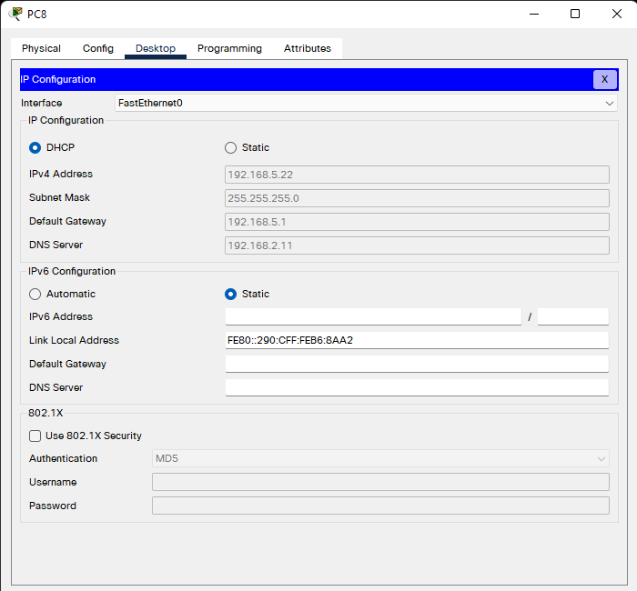

- Set IP address to Printer 3

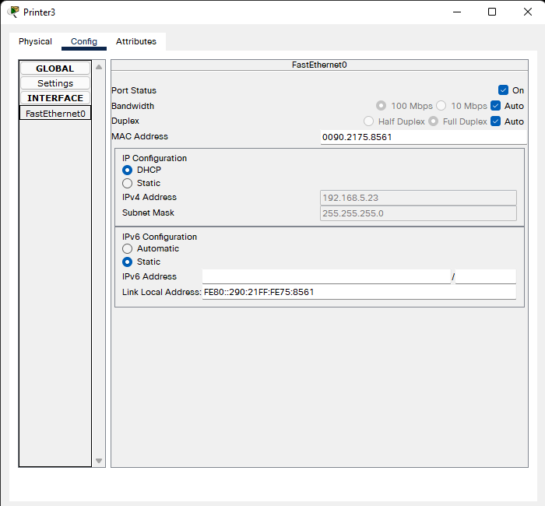

**Set IP address to devices in IT LAB Room 1**

- Set IP address to PC9

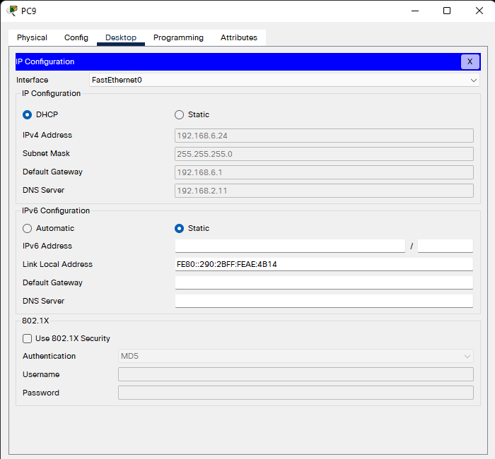

- Set IP address to PC10

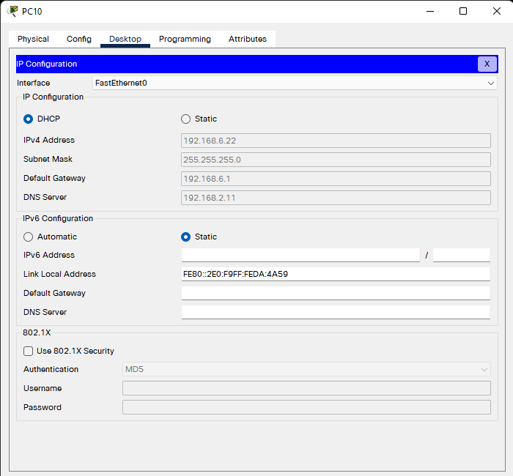

- Set IP address to PC11

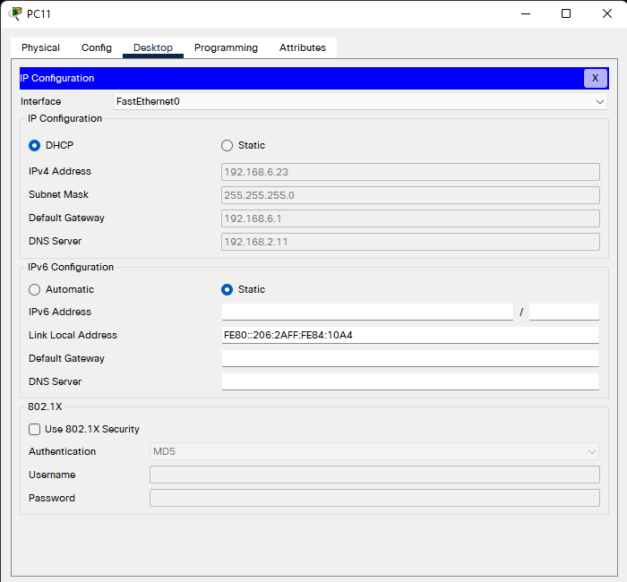

- Set IP address to PC12

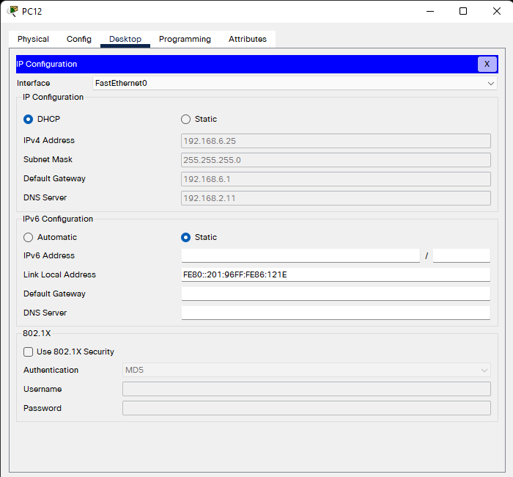

- Set IP address to PC13

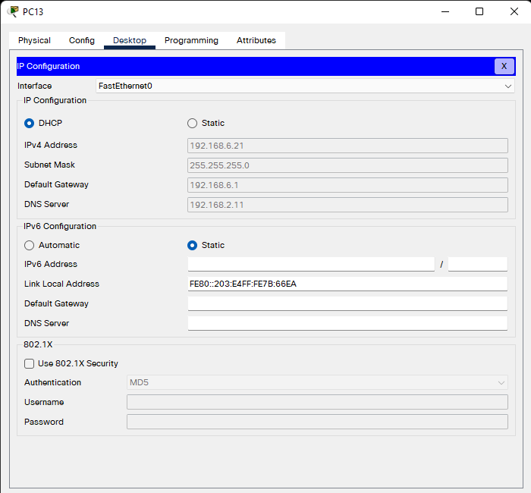

- Set IP address to PC14

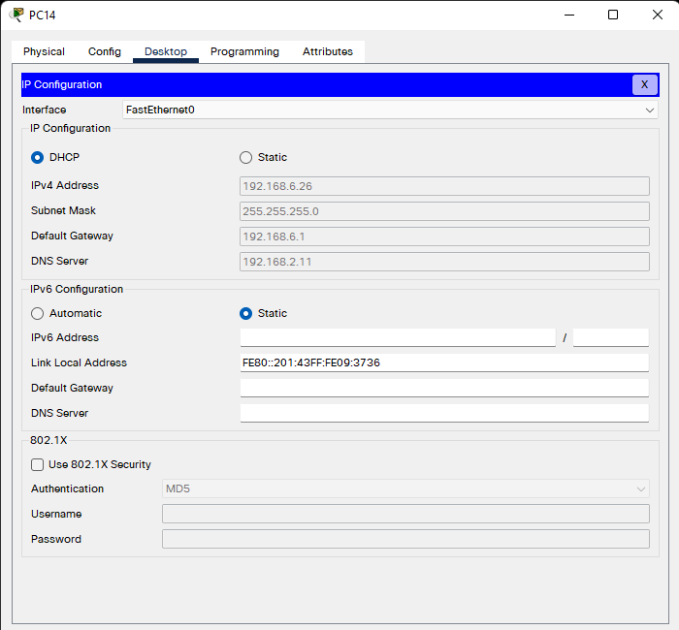

**Set IP address to devices in IT LAB Room 2**

- Set IP address to PC15

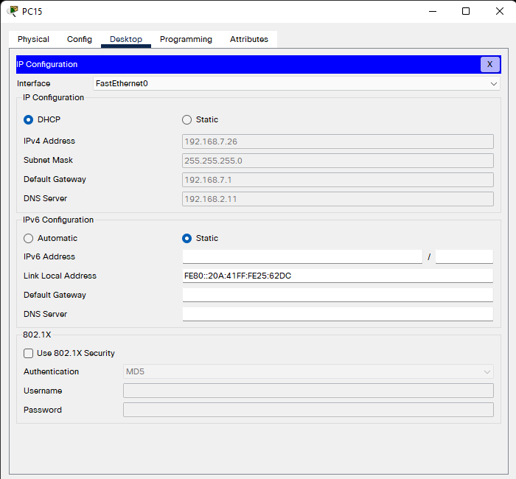

- Set IP address to PC16

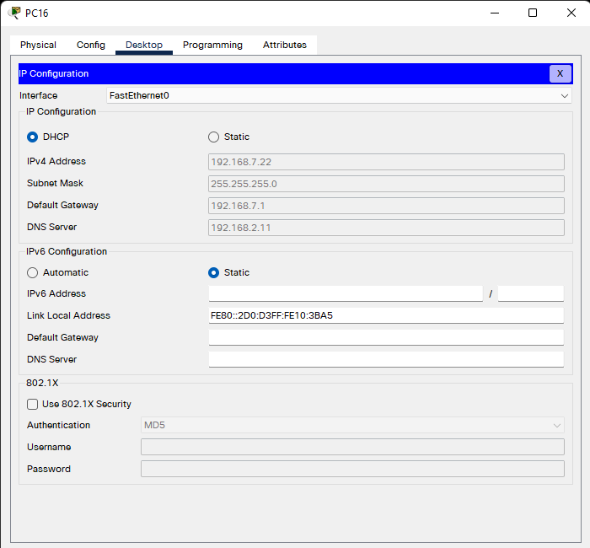

- Set IP address to PC17

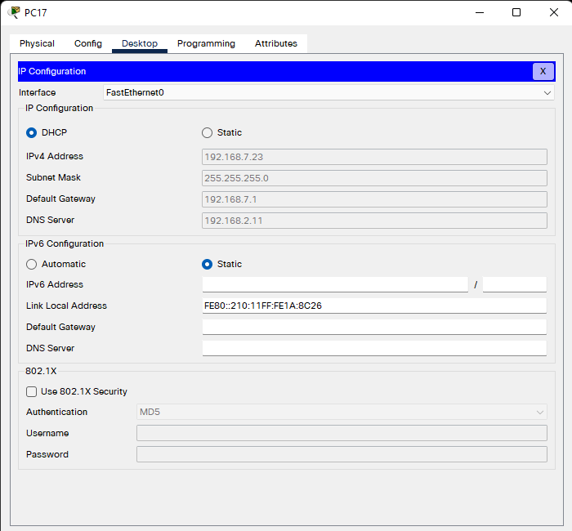

- Set IP address to PC18

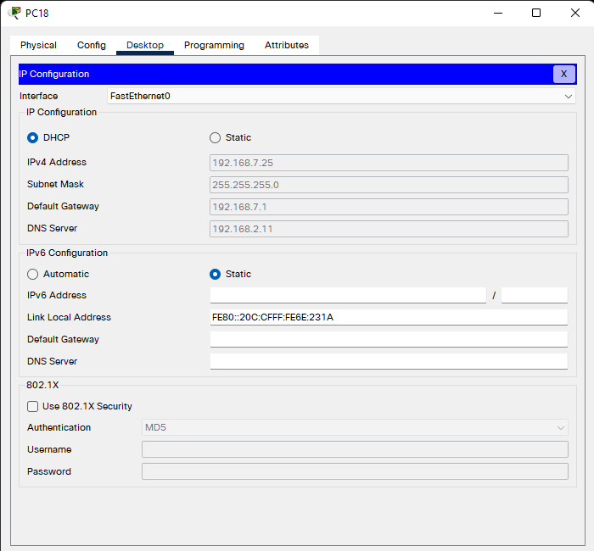

- Set IP address to PC19

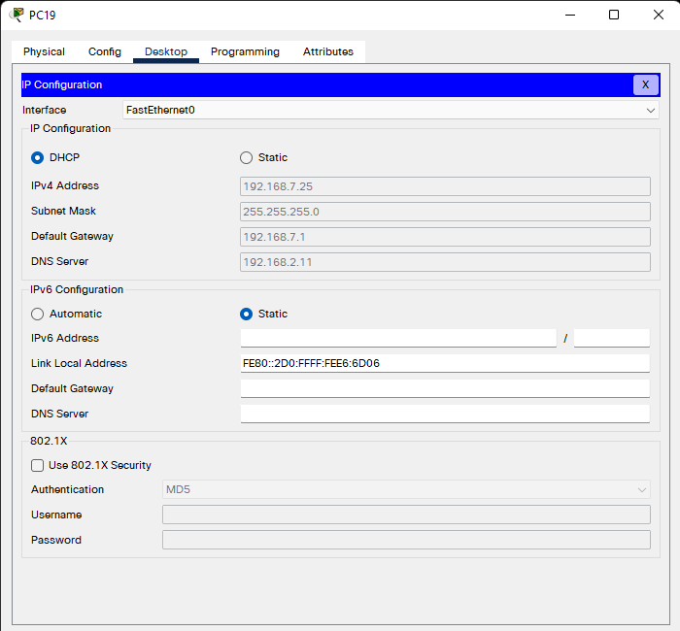

- Set IP address to PC20

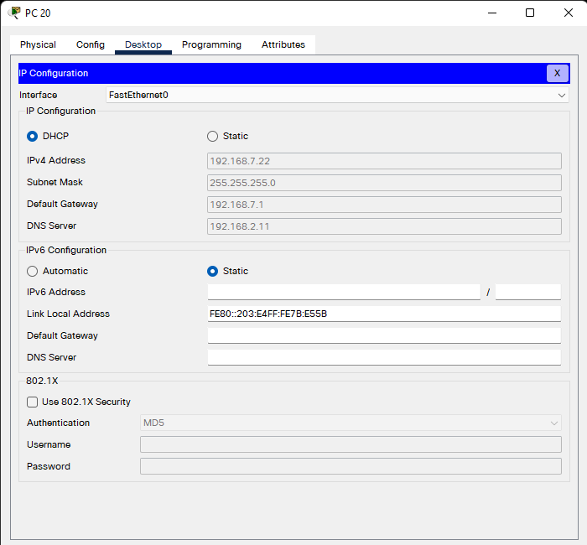

1. **Test the connection.**

**Ping from PC 4 to Web server**

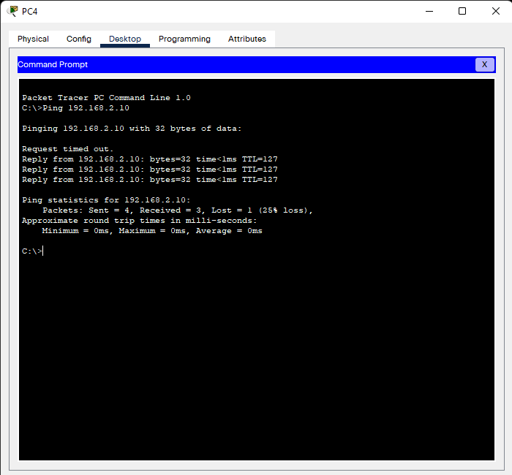

**Ping from PC5 to Printer 2**

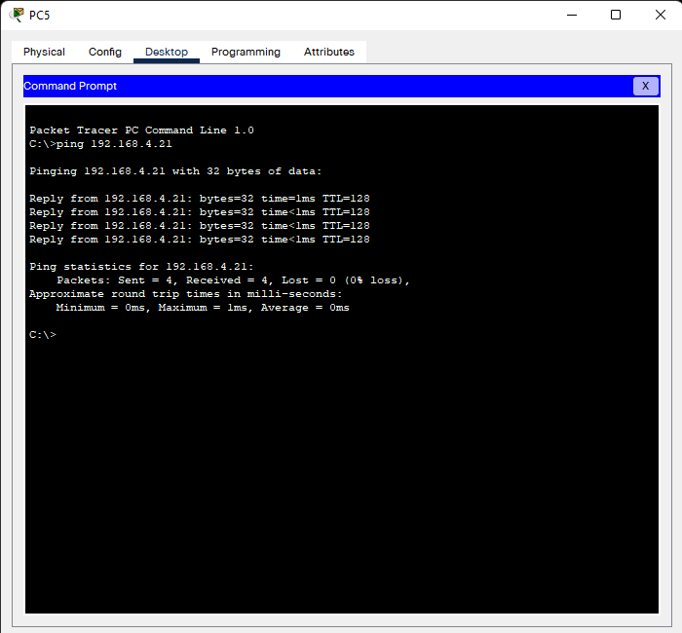

**Ping from PC1 to PC20**

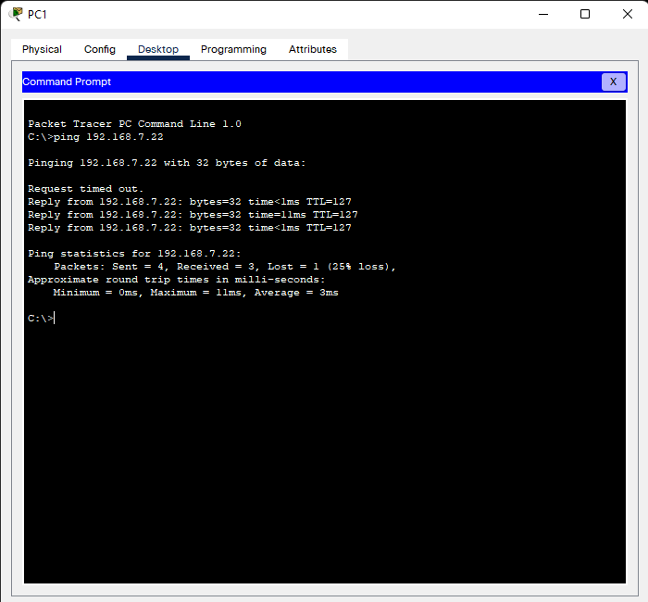

**Ping from PC15 to DNS server**

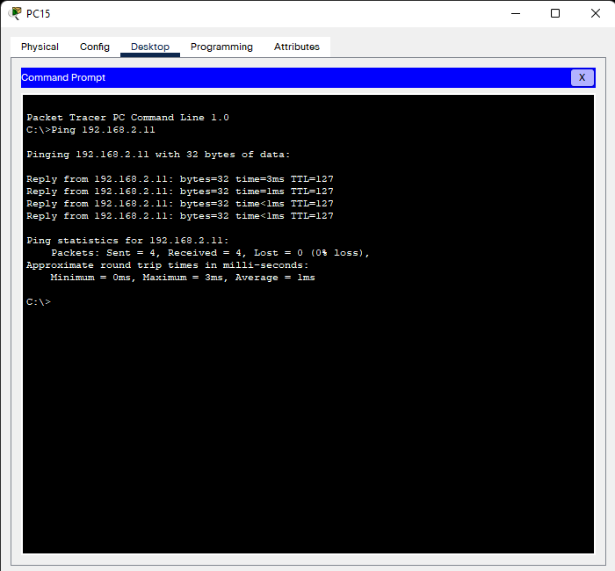

**Ping from PC10 to Mail server**

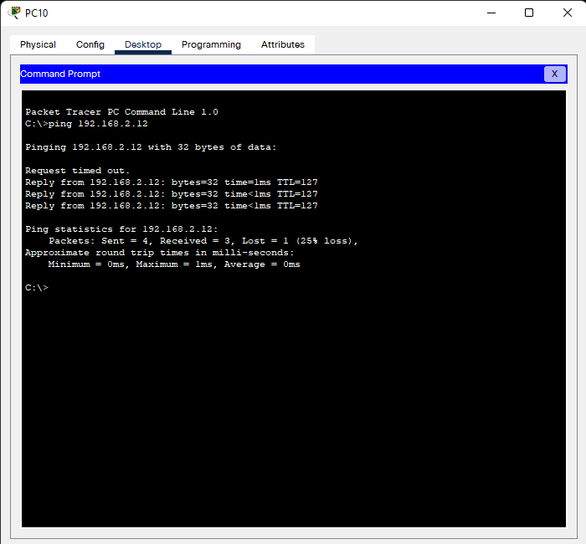

# References

GraduateWAY, 2021. *Graduateway.com.* [Online]   
Available at: https://graduateway.com/difference-logical-physical-design-network/